Thirroul Public School 2018
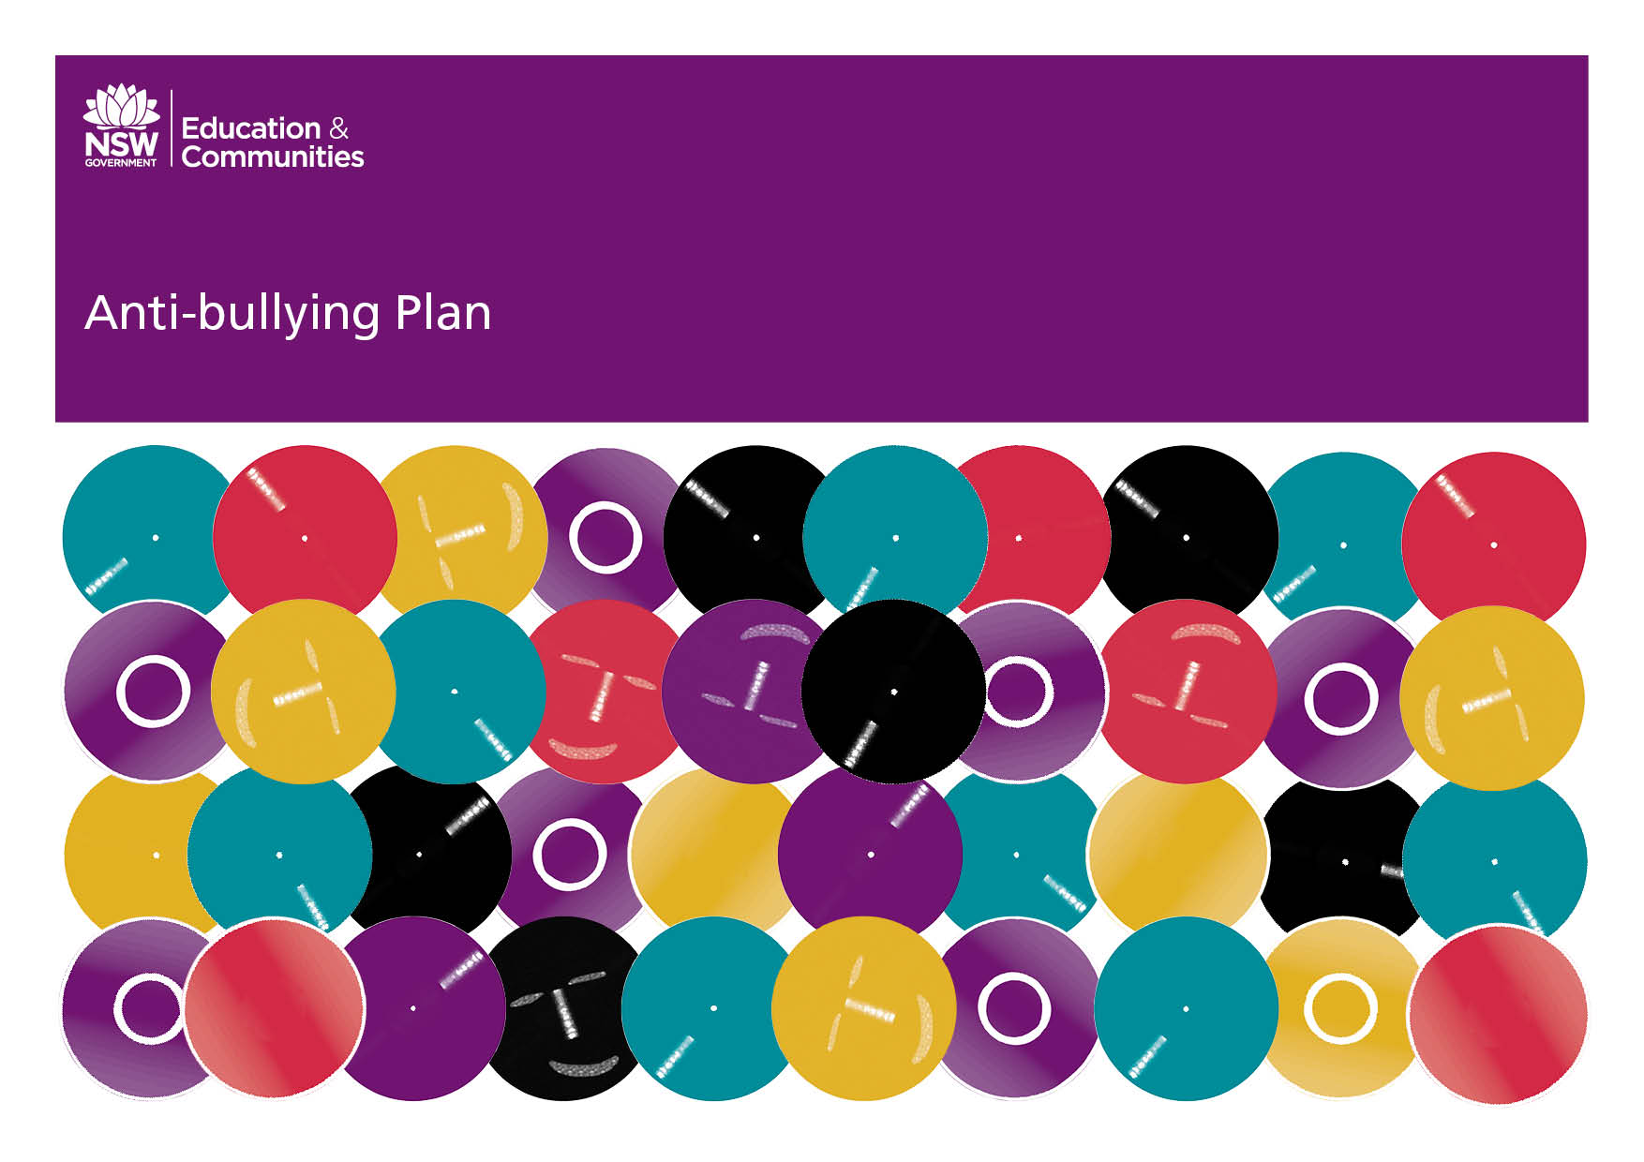

Bullying:
Preventing and Responding to Student Bullying in Schools Policy

The NSW Department of Education and Communities rejects all forms of bullying. No Student, employee, parent, caregiver or community member should experience bullying within the learning or working environments of the Department.

Bullying is repeated verbal, physical, social or psychological behaviour that is harmful and involves the misuse of power by an individual or group towards one or more persons. Cyber bullying refers to bullying through information and communication technologies.

Bullying can involve humiliation, domination, intimidation, victimisation and all forms of harassment including that based on sex, race, disability, homosexuality or transgender. Bullying of any form or for any reason can have long term effects on those involved including bystanders.

Conflict or fights between equals or single incidents are not defined as bullying.

Bullying behaviour can be:

- verbal e.g. name calling, teasing, abuse, putdowns, sarcasm, insults, threats
- physical e.g. hitting, punching, kicking,
scratching, tripping, spitting
- social e.g. ignoring, excluding, ostracising, alienating, making inappropriate gestures
- psychological e.g. spreading rumours, dirty looks, hiding or damaging possessions, malicious SMS and email messages, inappropriate use of camera phones.

The term “bullying” has a specific meaning. The school’s Anti-bullying Plan sets out the processes for preventing and responding to student bullying. The school has a range of policies and practices, including wellbeing and discipline policies that apply to student behaviour generally.

Schools exist in a society where incidents of bullying behaviour may occur. Preventing and responding to bullying behaviour in learning and working environments is a shared responsibility of all department staff, students, parents, caregivers and members of the wider community.

School staff have a responsibility to:

- respect and support students
- model and promote appropriate behaviour
- have knowledge of school and departmental policies relating to bullying behaviour
- respond in a timely manner to incidents of bullying according to the school’s anti-bullying plan.

In addition, teachers have a responsibility to:

- Provide curriculum and pedagogy that supports students to develop an understanding of bullying and its impact on individuals and the broader community.

Students have a responsibility to:

- behave appropriately, respecting individual differences and diversity
- behave as responsible digital citizens
- follow the school anti-bullying plan
- behave as responsible bystanders
- report incidents of bullying according to their school anti-bullying plan.

Parents and caregivers have a responsibility to:

- support their children to become responsible citizens and to develop responsible online behaviour
- be aware of the school Anti-bullying Plan and assist their children in understanding bullying behaviour
- support their children in developing positive responses to incidents of bullying consistent with the school Anti-bullying Plan
- report incidents of school related bullying behaviour to the school
- work collaboratively with the school to resolve incidents of bullying when they occur.

All members of the school community have a responsibility to:

- model and promote positive relationships that respect and accept individual differences and diversity within the school community
- support the school’s anti-bullying plan through words and actions
- work collaboratively with the school to resolve incidents of bullying when they occur.

Our School Anti-Bullying Plan

This plan outlines the processes for preventing and responding to student bullying in our school and reflects the Bullying: Preventing and Responding to Student Bullying in Schools Policy of the New South Wales Department of Education.

Statement of purpose

At Thirroul Public School every member of the school has the right to feel safe and protected so they can teach, learn and work productively. Bullying, harassment and other anti-social behaviour will not be tolerated in any form, including cyber-bullying. We believe in respect for ourselves, others and our environment. Working in partnership with students, parents, staff and our community we provide and promote a positive and supportive school environment. We work together to maintain a setting in which everyone feels valued and respected and where individual differences are appreciated, understood and accepted. This plan has been designed in consultation with staff, students and parents and has been ratified by the school community.
Protection

Bullying is an ongoing misuse of power in relationships through repeated verbal, physical and/or social behaviour that causes physical and/or psychological harm. It can involve an individual or a group misusing their power over one or more persons. Bullying can happen in person or online, and it can be obvious (overt) or hidden (covert).
Bullying of any form or for any reason can have long-term effects on those involved, including bystanders.
As a school we recognise and explore with students the different roles in a bully situation. These include:
- Bully/Perpetrator: the person responsible for an act of bullying,
- Target/Victim: the victim of an act of bullying and
- Bystander: a peer witness of the incident.

Bullying has three main features:
- It involves a misuse of power in a relationship
- It is ongoing and repeated, and
- It involves behaviours that can cause harm.
Single incidents and conflict or fights between equals, whether in person or online, are not defined as bullying.
Behaviours that do not constitute bullying include:
- mutual arguments and disagreements (where there is no power imbalance)
- not liking someone or a single act of social rejection
- one-off acts of meanness or spite
- isolated incidents of aggression, intimidation or violence.
However, these conflicts still need to be addressed and resolved.
Students identified as victims or perpetrators in bullying incidents may take part in assertive or remedial social skills programs to help improve their skills and strategies in managing and maintaining respectful relationships.

Prevention
At Thirroul Public School we encourage students to develop strong, positive relationships with their peers, develop networks of support and report any ongoing problems to a staff member. Students participate in wellbeing initiatives and programs that are embedded in our curriculum that promote respectful relationships, cohesiveness, tolerance, resilience and social skills.

Preventative strategies
- Participate in wellbeing initiatives and social and emotional skills programs to promote tolerance, resilience, conflict resolution, assertiveness and problem solving throughout the school,
- Teachers model appropriate behaviour and share common language,
- Lunch time play activities supervised by the Learning and Support Officers,
- Anti-bullying posters prominently displayed around the school,
- Peer support programs and buddy programs,
- Positive rewards for appropriate behaviour,
- Student Wellbeing Team which monitors and tracks student behaviour,
- Intervention for students who engage in bullying behaviours and students who are bullied,
- Individual support programs for students and
- School Anti-Bullying Policy outlining firm action and appropriate consequences. This could include being placed on a Level or Suspension as outlined in the Student Discipline in Schools Policy

It is important that as a school community we continue to promote positive, respectful relationships to sustain the friendly and safe school environment at Thirroul Public School.

Indicators of Bullying

Possible indicators of bullying may include:
- Under achievement or disinterest in class work,
- Refusing to attend school,
- Personality change- snappy, withdrawn or tired,
- Loss of appetite,
- Lack of confidence, withdrawn from social activities,
- Temper flare-ups, abusive language or impulsive behaviour,
- Avoidance of specific lessons/days,
- Change routine (route to school/home),
- Late for school or staying late at school,
- Desire to work or play near supervising teacher,
- Torn or damaged clothing and belongings,
- Bruises and cuts,
- Psychosomatic illnesses,
- Jumpiness, forgetfulness, distractibility,
- Denial of witnesses reports and
- Reports from self, peers, parents.
We encourage students to discuss situations with teachers and to seek help, if they feel unsafe. Any students of concern should be referred to Student Welfare Team and Assistant Principal (Welfare) where the Student Welfare Team will consult with students, staff and parents. An individual behaviour plan may be developed for students identified as engaging in bullying behaviour, or identified as a victim of bullying. The School Counsellor may be involved in this plan.

What is conflict?
It is important for teachers, parents and students to understand and reinforce the difference between bullying and conflict. The normal day to day interpersonal clashes and disagreements are a part of everyday life and humans need to learn how to resolve conflict, in a meaningful way. Being able to solve minor conflict in friendship and peer groups is a normal and important aspect of student growth and development. By being able to solve conflict students are developing resilience, independence and social skills.
Response

The strategies and programs that Thirroul Public School implements to support students who have been affected by, engaged in or who have witnessed bullying behaviour include the following:

- Students are encouraged to initially let the offender/s know that their actions are not wanted.
- If the offender does not cease their actions, students are to report their concerns to a teacher.
- After initial investigation with student/s involved, the teacher will complete a Classroom Incident Sheet or a Playground Incident Sheet. These are placed in the Playground Folder or the Student Welfare Box (this is located in the staffroom). Behaviour is monitored and responded to in accordance with the TPS Student Wellbeing Policy.
- If there is an urgent situation, teachers will bring the incident to the immediate attention of the Stage Assistant Principal or the Principal.
- Once a concern has been reported, the Assistant Principal will interview the alleged offender and a warning or disciplinary consequence will be delivered and tracked, depending on the circumstances and seriousness of the case.
- Parents of both parties may be contacted by the school.
- It may be necessary to have a meeting with the parents/carers of either party. This meeting may be conducted by an Assistant Principal or Principal as appropriate.
- If the bullying or harassment continues, appropriate disciplinary action will be determined by the Assistant Principal or Principal.

Relieving Principal: Lisa Lupton Roxburgh Avenue (PO Box 254) Thirroul NSW 2515 T 02 4267 1469 F 02 4268 1463
E Thirroul-p.school@det.nsw.edu.au www.thirroul-p.schools.nsw.edu.au ABN 94 242 158 301
A proud member of the Sea Cliff Community of Schools – The cliff behind, the sea in front, our future ahead

School Contact Information
Email: Thirroul-p.school@det.nsw.edu.au
Phone: 4267 1469

Additional Contact Information

Kids Help Line: 1800 55 1800

Headspace: https://headspace.org.au

Lifeline: 13 11 14

Beyond Blue: 1300 22 4636
https://www.beyondblue.org.au

RUOK? https://www.ruok.org.au

Bullying. No Way! https://bullyingnoway.gov.au

National Centre Against Bullying: https://www.ncab.org.au

Office of the eSafety Commisioner: https://www.esafety.gov.au

Kids Matter: https://www.kidsmatter.edu.au

Safe Schools Hub: https://www.studentwellbeinghub.edu.au

